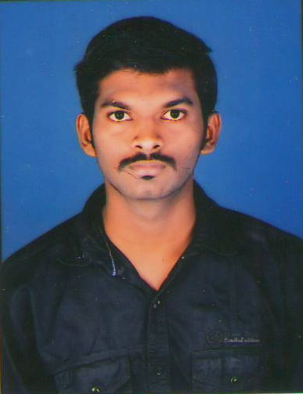

RAHUL KAMBLE
P.T Dindayal Upadhaya Marg,
Mulund (West) Mumbai 400080
kamble.rahul843@gmail.com

CAREER OBJECTIVE

To use my skills in the best possible way for achieving the company’s goals & work in a firm with a professional work driven environment for a long term, which provides me job satisfaction and self-development with the cutting edge of technologies.

BASIC ACADEMICS QUALIFICATIONS

Qualification | Board/University | Year | Percentage
MBA  (Marketing & Finance) | “Annapoorna Institute Management Research”  Affiliated to Rani Channamma University | 2014-16 | 62.00 %
B.COM | “Ramanand Arya D.A.V College”  Affiliated to Mumbai University | 2014 | 51.92 %
Intermediate | Dayanand Vedic Vidyalaya | 2009 | 55.17 %
High School | Navbharat Nutan Vidyalaya | 2007 | 42.15%

INTERPERSONAL SKILL

- Ability to rapidly build relationship and set up trust.
- Self-confidence
- Active listening
- Can absorb quickly and contribute productively.
- Ability to cope up with different situations.

IT PROFICIENCY

- Certificate of achievement in IT Knowledge.
- Certificate of achievement in Hardware (A+) & Networking (N+)
- Microsoft Office Word, Microsoft Office Excel, Microsoft Office Power Point

EXPERIENTIAL LEARNING (STUDENT INTERNSHIP PROGRAM)

- Company Name : - WESTERN SOLAR SYSTEMS
- Project Title : - A Study on Solar as a Catalytic Agent in Economic Growth
- Duration : - 3 Months

PROJECT REPORT

- Financial Enhancement & Market Potential.

WORK EXPERIENCE

- Matrix Cellular International Services as the B.D.E (August 2016 to April 2017)
- Identifying new sales leads & Pitching products and services
- Maintaining fruitful relationships with existing customers
- Contacting potential clients via email or phone to establish rapport and set up meetings
- Researching organizations and individuals to identify new leads and potential new markets

- My Computers as the Business Development Executive in (October 2014 to January 2016)
- Generating business leads and following up on sales opportunities.
- Building relationships with potential customer’s establishment of their requirements.
- Following up swiftly on sales enquiries and sending out information.
- Working closely with other teams to develop new business.

- Aptech ltd on CMAT as Technical Support Administrator (July 2013 to February 2014).
- Prioritize and manage several open issues at one time
- Diagnose and troubleshoot basic technical issues
- Handling remote servers & client systems applications and software

- Reliance Communication as Customer Representative in (December 2012 to June 2013) .
- Providing information about products and services.
- Maintains customer records by updating account information
- Dealing with customers unsatisfied with the quality of the product or service
- Responding to negative press about the company

PERSONAL DETAILS

Name : Mr. Rahul Kamble
Date of Birth : 23rd April 1991
Nationality : Indian
Mobile No. : 08898218465, 08169278370
Alternate E-mail : rk.rahulking91@gmail.com
Address : Mulund (west) Mumbai 400080
Languages Known : English, Hindi, and Marathi

DECLARATION

I hereby declare that the above mentioned information is true and best of my knowledge. I’m assuring you of sincerity & dedication to learn.

Place:
Date: (RAHUL KAMBLE)

